Event plan
North Sea Energy Summit 2026 · Hamburg · 22–24 September 2026 · Booth B4.210
Noah Fischer · 10 September 2026 · WE-MC-EVT-2026-01
Owner: Noah Fischer · Core team: Leah Goldberg, Ravi Shah, Henrik Larsen (Business Development), Nina Petrova (Recruiting) · Executive sponsor: Dr. Amara Okafor

1. The event
The North Sea Energy Summit 2026 takes place at Hamburg Messe from 22 to 24 September 2026. The organisers expect around 14,000 visitors and 480 exhibitors from the offshore wind, grid, hydrogen and maritime sectors. As a Hamburg company in the middle of building Harrow Bay, this is our home game – and the first time we exhibit with our own stand rather than on a partner booth.
Item | Detail
Dates | Tue 22 – Thu 24 September 2026, 09:00–18:00 (Thu until 16:00)
Venue | Hamburg Messe, Hall B4
Our booth | B4.210 – island stand, 10 × 8 m (80 m²), aisle 21
Build-up | Sat 19 – Mon 21 September
Dismantling | Thu 24 September from 16:30, Fri 25 September
Keynote | Dr. Amara Okafor, Main Stage, Tue 22 Sep, 10:30–11:00
Panel | Elena Márquez, 'Delivering offshore wind on time', Stage 2, Wed 23 Sep, 14:00
Reception | Co-hosted networking evening, Wed 23 Sep, 19:00, harbour-side venue

2. Objectives
Objective | KPI | Target
Generate business leads (offtakers, suppliers, partners) | Qualified leads scanned | 120 (≥ 20 A-leads)
Recruit for Harrow Bay and engineering | Candidate conversations / applications | 60 / 30
Position Weyland as a builder | Keynote audience, media mentions | 700 / 25
Strengthen key relationships | Pre-booked meetings at the booth | 35

3. Booth concept
The stand follows the Powering the North campaign: light oak, Deep Sea walls, teal accents and a 4.4 m LED wall running the campaign loop and live Harrow Bay progress. At the centre a 1:100 model of the Halden HTS-12 turbine on its monopile (on loan from Halden Turbine Systems, arranged via Lars Henriksen) gives visitors a reason to stop. Two meeting rooms and a lounge for pre-booked meetings; a careers wall with QR codes to open roles.
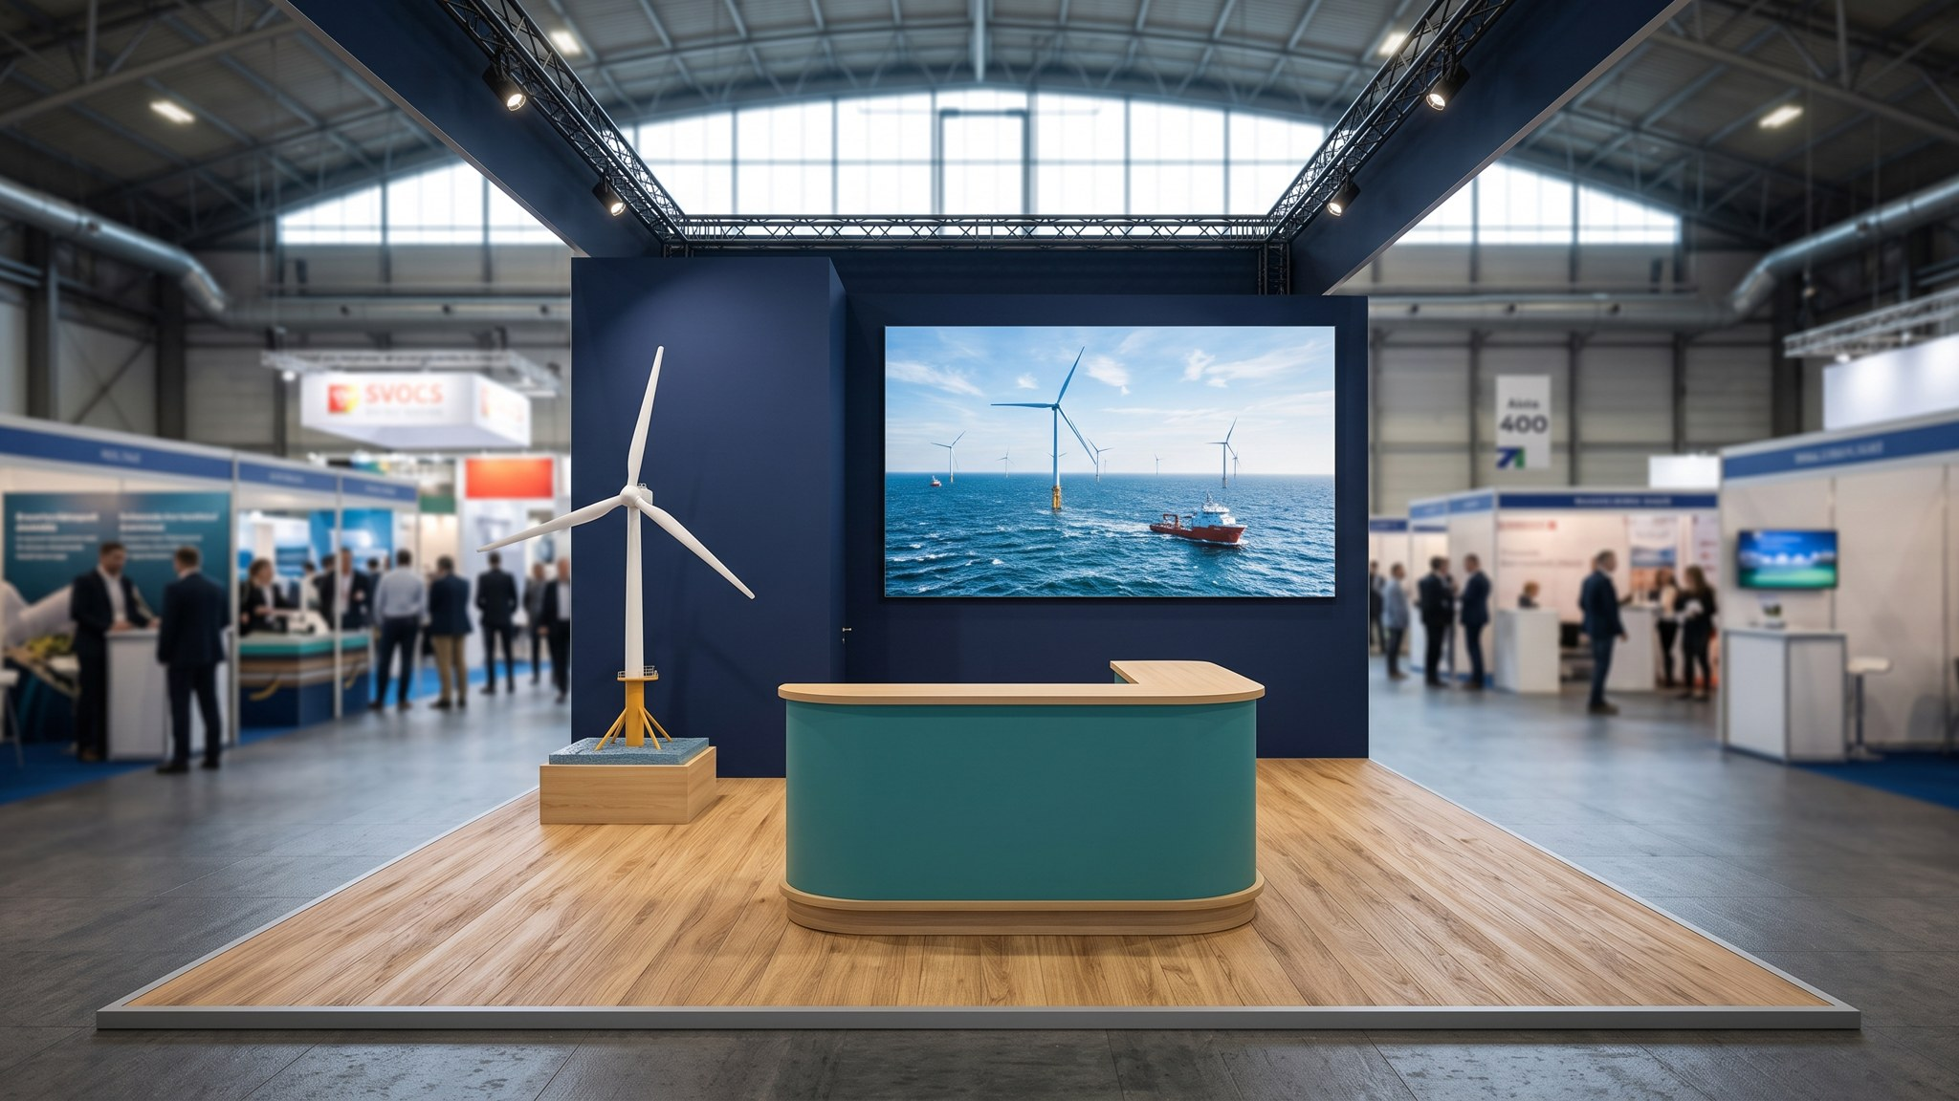
Rendering of the stand, front view (Messebau Kranz, Rev. B).

4. Programme highlights
- Keynote – 'From steel to sea: building the North Sea's next decade' (Dr. Amara Okafor)
- Panel – Elena Márquez with Halden Turbine Systems, Severn Subsea Cables and NordGrid Transmission
- Daily booth talks at 11:30 and 15:30: Harrow Bay construction (Felix Brandt), green hydrogen at Eastholm (Isabel Ferreira), battery storage (Kwame Mensah)
- Careers hour Wed 16:00–17:00 with Nina Petrova and Julia Hoffmann

5. Budget
Approved budget EUR 185,000 (Marketing budget 2026). Detailed plan and actuals in Event Budget.xlsx.

6. Timeline
Deadline | Task | Owner
31 Jan | Exhibitor contract signed | Noah Fischer
15 Mar | Stand builder selected (3 quotes) | Noah Fischer
30 Apr | Keynote slot confirmed | Noah Fischer
15 Jun | Booth design final (Rev. B) | Ravi Shah
30 Jun | Hotels booked | Leah Goldberg
31 Jul | Giveaways ordered | Leah Goldberg
15 Aug | Staffing rota final | Noah Fischer
1 Sep | Graphics print files delivered | Ravi Shah
14 Sep | Keynote rehearsal | Dr. Amara Okafor
2 Oct | Post-event report | Noah Fischer

7. Risks
Risk | Mitigation
Questions about the export cable delay (HB-RISK-017) at the booth or on the panel | Holding statement and Q&A briefed to all booth staff
Turbine model damaged in transport | Halden ships in its own crate; insurance via exhibition policy
Staff pulled away by project work | Back-up names in rota; Elena only on Wednesday
Millbrook protest group at the stand | Unlikely in Hamburg – Tom Berger briefed as contact

